Douglas Mcmahon

[Draw your reader in with an engaging abstract. It is typically a short summary of the document. When you’re ready to add your content, just click here and start typing.]

Energuide Home Analysis

UDA Unit 12 Final Assignment

Contents

Energuide Data Analysis 1

References 6

Figure 1: Currently Yearly Spending on Space Heating 2

Figure 2: Cost of Replacing Furnaces per Home 3

Figure 3: Grand Total of Cost for All Homes to Replace Furnaces 3

[Figure 5: Most Expensive Home Based on Source of Expense 4](https://norquest-my.sharepoint.com/personal/dmcmahon_norquest_ca/Documents/Documents/Energuide%20Data%20Analysis%20Final.docx#_Toc170662366)

[Figure 4: Most Expenseive Home for Heating Cost 4](https://norquest-my.sharepoint.com/personal/dmcmahon_norquest_ca/Documents/Documents/Energuide%20Data%20Analysis%20Final.docx#_Toc170662367)

Figure 6: Least Expensive Home in Poll 5

Figure 7: Least Expensive Home Based on Expense 5

Figure 8: Total Combined Savings of Top Five Homes with New Furnaces 6

Figure 9: Each of the Top Five Homes Savings With New Furnaces 6

# Energuide Data Analysis

This report is based on the figure provided in the website ucahelps.alberta.ca (Alberta Government, 2024) from May of 2024.

This chart represents the amount currently spent per year on the polled 26 homes from Energuide on space heating.

|  |
| --- |
| [C:\Users\Student\AppData\Local\Microsoft\Windows\INetCache\Content.MSO\71386A58.tmp](https://app.powerbi.com/MobileRedirect.html?action=OpenReport&reportObjectId=8f3f0bde-daaf-4807-a51f-eb6aff08b1f2&ctid=2ba011f1-f50a-44f3-a200-db3ea74e29b7&reportPage=c098c11a7a39d044699d&pbi_source=copyvisualimage)  Figure : Currently Yearly Spending on Space Heating |
|  |

The next chart represents how much money could be saved by Energuide homes if all of the polled 26 homes each got new furnaces.

|  |
| --- |
| [C:\Users\Student\AppData\Local\Microsoft\Windows\INetCache\Content.MSO\AC81283E.tmp](https://app.powerbi.com/MobileRedirect.html?action=OpenReport&reportObjectId=8f3f0bde-daaf-4807-a51f-eb6aff08b1f2&ctid=2ba011f1-f50a-44f3-a200-db3ea74e29b7&reportPage=8e7745eed9d531021f20&pbi_source=copyvisualimage)  Figure : Cost of Replacing Furnaces per Home |
|  |
|  |
| [C:\Users\Student\AppData\Local\Microsoft\Windows\INetCache\Content.MSO\3A608A6A.tmp](https://app.powerbi.com/MobileRedirect.html?action=OpenReport&reportObjectId=8f3f0bde-daaf-4807-a51f-eb6aff08b1f2&ctid=2ba011f1-f50a-44f3-a200-db3ea74e29b7&reportPage=8e7745eed9d531021f20&pbi_source=copyvisualimage)  Figure : Grand Total of Cost for All Homes to Replace Furnaces |
|  |

This chart represents the most consumptuous home based on the polling of the 26 homes from Energuide and its associated cost.

[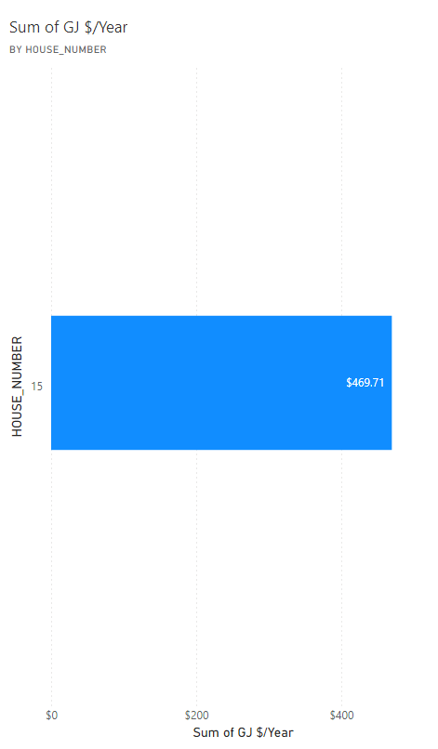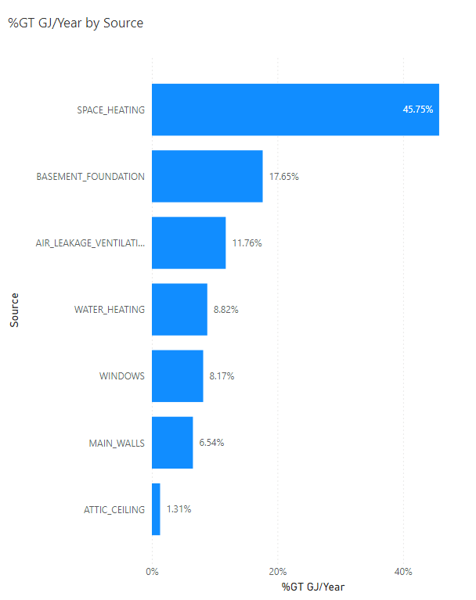](https://app.powerbi.com/MobileRedirect.html?action=OpenReport&reportObjectId=8f3f0bde-daaf-4807-a51f-eb6aff08b1f2&ctid=2ba011f1-f50a-44f3-a200-db3ea74e29b7&reportPage=6a6ad924e5d8c21561bc&pbi_source=copyvisualimage)

Figure : Most Expensive Home Based on Source of Expense

Figure : Most Expenseive Home for Heating Cost

|  |
| --- |
| These charts represent the least expensive home polled in the Energuide homes and their expense per source of upgrade. |
|  |
|  |
|  |

|  |
| --- |
| [C:\Users\Student\AppData\Local\Microsoft\Windows\INetCache\Content.MSO\D7070486.tmp](https://app.powerbi.com/MobileRedirect.html?action=OpenReport&reportObjectId=8f3f0bde-daaf-4807-a51f-eb6aff08b1f2&ctid=2ba011f1-f50a-44f3-a200-db3ea74e29b7&reportPage=ee0b9491e01b8c8f7819&pbi_source=copyvisualimage)  Figure : Least Expensive Home in Poll |
| [C:\Users\Student\AppData\Local\Microsoft\Windows\INetCache\Content.MSO\BFFF4732.tmp](https://app.powerbi.com/MobileRedirect.html?action=OpenReport&reportObjectId=8f3f0bde-daaf-4807-a51f-eb6aff08b1f2&ctid=2ba011f1-f50a-44f3-a200-db3ea74e29b7&reportPage=ee0b9491e01b8c8f7819&pbi_source=copyvisualimage) |
| Figure : Least Expensive Home Based on Expense |
|  |

These charts represent the 5 homes that would save the most money if they installed new furnaces in the Energuide homes based on saved values.

|  |
| --- |
| [C:\Users\Student\AppData\Local\Microsoft\Windows\INetCache\Content.MSO\48123E9E.tmp](https://app.powerbi.com/MobileRedirect.html?action=OpenReport&reportObjectId=8f3f0bde-daaf-4807-a51f-eb6aff08b1f2&ctid=2ba011f1-f50a-44f3-a200-db3ea74e29b7&reportPage=f5b58c7713aa0a9e45c5&pbi_source=copyvisualimage)  Figure : Total Combined Savings of Top Five Homes with New Furnaces |
| ) |
| [C:\Users\Student\AppData\Local\Microsoft\Windows\INetCache\Content.MSO\361ED6CA.tmp](https://app.powerbi.com/MobileRedirect.html?action=OpenReport&reportObjectId=8f3f0bde-daaf-4807-a51f-eb6aff08b1f2&ctid=2ba011f1-f50a-44f3-a200-db3ea74e29b7&reportPage=f5b58c7713aa0a9e45c5&pbi_source=copyvisualimage)  Figure : Each of the Top Five Homes Savings With New Furnaces |
|  |

# References

Alberta Government. (2024). *Utilities Consumer Advocate.* Retrieved from Regulated Rates - Year at a Glance: https://ucahelps.alberta.ca/regulated-rates.aspx